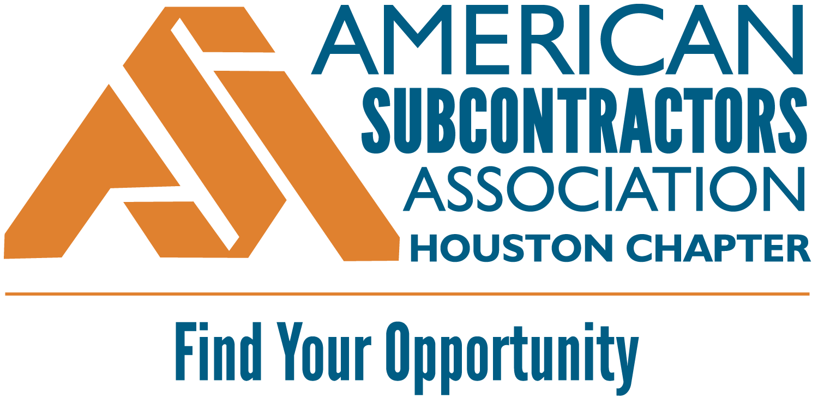
2025 SAFETY RECOGNITION AWARD
ENTRY FORM
Requirements:
- ASA Houston member in good standing
- Member of the 2024-25 ASA Houston Commitment to Safety Program (at any level)
- Company representation and participation in ASA Houston Safety Committee
- Photo(s) and/or related document(s) to accompany your nomination.
Contact Info:
COMPANY NAME:
CONTACT NAME:
CONTACT EMAIL:

Essay:
In 500 words or less, describe your company’s formal safety and health program and the various ways your company goes above and beyond to ensure a safe workforce:

Items to consider in your entry: Describe your company’s safety culture. What do you think differentiates your company’s safety program from that of other subcontractors in the Houston area? Do you have a designated safety professional on staff? Do you conduct regular site inspections? What kind of safety training does your company provide for employees? How many man-hours did your company work in the past year and what is your current EMR? What industry safety awards or recognitions has your company received? Has any individual person in your company been recognized with any other industry safety awards?
Award Entry Instructions:
Please complete this form and email it to asa@asahouston.org with the following subject line:

ASA Houston Safety Award Entry: [company name]

Judging: Judges will consist of randomly selected safety professionals from ASA GC Partner companies.
Judges will rate each entry on a scale of 1 through 10. The company with the highest score will win.

Winner: The winning member will be recognized at the ASA Houston Awards Luncheon on May 8, 2025 as well as at the National ASA Conference in Oklahoma City, OK on September 16-18, 2025.

ENTRY DEADLINE: MARCH 28, 2025

