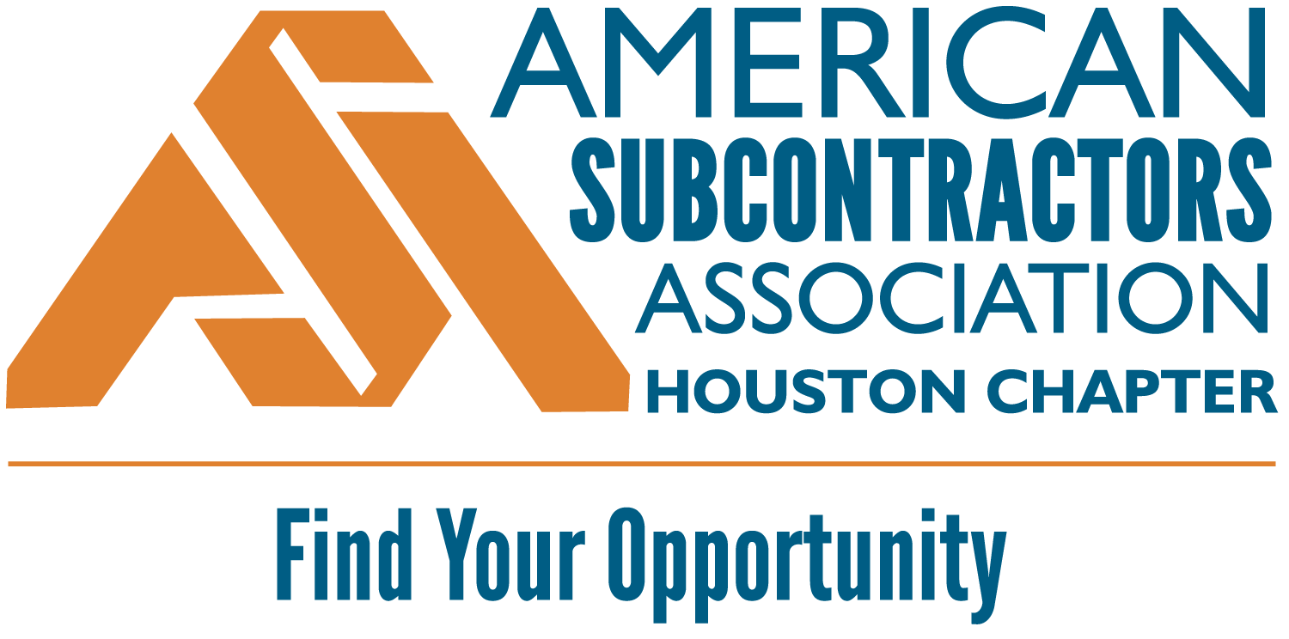
2026 SUBCONTRACTOR FOREMAN
OF THE YEAR AWARD
ENTRY FORM
This award recognizes an outstanding foreman who demonstrates exceptional leadership, craftsmanship, and dedication in managing crews and delivering high-quality work safely and efficiently.

Nominees may be nominated by supervisors, peers, or company leadership.

Requirements:
- Nominee must be actively working in their respective role during the award period (June 1, 2025 – present)
- Nominee must be an employee of an ASA Houston subcontractor member company in good standing
- Photo(s) and/or related document(s) to accompany your nomination.

Contact Info:
COMPANY NAME:
CONTACT NAME:
CONTACT EMAIL:

Essay:
Nominated Individual:
Nominated Individual Email:
Nominated Individual Cell:
In 500 words or less, describe a foreman who goes above and beyond in managing crews, maintaining safety standards, delivering high-quality work, and ensuring projects are completed efficiently and on schedule:

Key Areas of Excellence: Leadership & Team Management; Safety Commitment; Quality of Workmanship Productivity & Efficiency; Problem-Solving & Initiative; Communication; Professionalism & Integrity

Award Entry Instructions:
Please complete this form and email it (along with photos) to asa@asahouston.org with the following subject line:

ASA Houston Subcontractor Foreman Award: [company name]

Judging: Judges will consist of 5 randomly selected industry leaders not affiliated with an ASA member company.
Judges will rate each entry on a scale of 1 through 10. The entry with the highest score will win.

Winner: The winning individual will be recognized at the ASA Houston Awards Luncheon on May 21, 2026 as well as at the National ASA Conference in Bonita Springs, FL on September 29 – October 1, 2026.

ENTRY DEADLINE: APRIL 17, 2026

